HATS IN
AND MOVING TO
THE ROCKY MOUNTAINS
1800-1840
by Gene Hickman

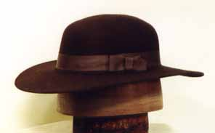
The most popular and most dominant hat style documented seems to be the low round crowned, wool felt hat with a wide brim. If you are wearing this style you’ll probably not have a “correctness” issue.

Before anymore discussion of hats I would refer you to the information in the article on Clothing & Accoutrements In and Moving to the Rocky Mountains. Again it will depend upon the time frame, where the individuals came from such as Canada, Spanish Southwest, the States, or their ethnic origins, etc. Sometimes it would be easier to say what we are fairly sure they did not have or wear, just by observing some of the hats worn at modern rendezvous. Modern buckskinners & Hollywood tend toward what looks good, so they wear it, others see it, and still others imitate it assuming it is correct. Here is a list of what we can not yet document: leather hippie style hats, full drape animal skin “road-kill” hats, floppy shapeless “hill-billy” hats, hats with creased or shaped crowns, “Davey Crockett” style coonskin caps, and the little “pill-box” beaver skin hat with the leather bill, and head scarves worn in the “pirate-style”. There are thousands of pages of journals, invoices, other fur trade records, field sketches and paintings that have been reviewed and still probably thousands of more that have not been reviewed. Consequently some of these hats may turn up. If anyone can find documentation or period sketches/paintings of these items we would be very interested in them, and we will add them to this hat article. So far we have been unable to find any documentation for these.

Here are some good references for hats in our time and place: Allen Chronister and Clay Landry’s article on Clothing of the Rocky Mountain Trapper 1820-1840 in The Book of Buckskinning VII, James A. Hanson’s sketchbooks - The Voyager’s Sketchbook and The Mountain Man’s Sketch Books, Rex Allen Norman’s The 1837 Sketchbook of the Western Fur Trade, and Shawn Webster’s In the Image of A. J. Miller. Some of these references will have examples that go beyond our 1840 time period, so look closely at what they say. Most have good sketches of appropriate hats. There are a number of artists that have also left us some visual information, but some of these artists painted or sketched after the 1840 time frame. Consequently, all of their sketches/paintings are probably accurate, but then again they may not be accurate for our time and place. You just need to be aware of this and make your own decision. Then there is always the question of artistic “license.” Here are some of the artists, from before, during and after our time period, in random order: Rindisbacher, Hind, Bingham, Miller, Kurz, Ranney, Krieghoff, Hopkins, Point, Bodmer and Meyer. Additionally you may want to look at hat makers such as Clearwater Hats (http://www.clearwaterhats.com/furtradepageone.htm) who have well researched reproduction of hats. This may perhaps, not only be a good place to purchase a hat, but it will let you can see some examples. There are probably others good hat makers and distributors out there too, Clearwater is used as one example.

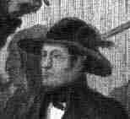
Karl Bodmer’s painting of Prince Maximilian (1833-34) visiting the Minetarees at Fort Clark, shows the low crowned wide brimmed hat. Karl Bodmer, Paulus Lesser, courtesy Rare Book Division, The New York Public Library, Astor, Lenox and Tilden Foundations

Again, the most common hat, and what seems to be the hat style of choice, is wool felt, round low crown and broad-brimmed, often referred to in the historic record as just wool hats. They have predominately round crowns, although a few have flat crowns and the flat crown seems to gain some popularity at the end of the 1830s. Crowns average from 3 ½” to 5” high and most brims seem to be around 3”- 5”. Rufus Sage, Rocky Mountain Life, says that the mountaineer wore …a low crowned wool-hat, or a rude substitute of his own manufacture.

March 1834: Capt Wyeth …accompanied us to a store in the town, and selected a number of articles for us, among which were ….white wool hats, with round crowns, fitting tightly to the head, brims five inches wide, and almost hard enough to resist a rifle ball (J.K. Townsend, 1839. Narrative of a Journey across the Rocky Mountains to the Columbia River)

These hats may be napped or smooth and may often be referred to in the historic inventories as napped. Napped hats seem to be more prevalent in the early 1800s and gradually become less common by the 1830s, at least in the record:

2 Doz. Napped Hats [for] $192…Memorandum of goods for Mess. Gardner & Williams pr their order (Inventory of Goods available at the 1825 Rendezvous on Henry's Fork of the Green River (cached goods listed in Ashley's diary).

None of the hats that we found reference for or that are illustrated, seem to have creased crowns. Creasing of crowns and taller crowns become more commonly documented in the mid-1800s. In George Bingham’s genere paintings along the Missouri river in the 1850s we see a few hats with flat tops and a “doughnut” crease in the top.
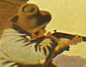 From Bingham’s 1850 “Shooting the Beef.”

However, even by the Civil War most civilian hats and many military hats do not have creased crowns, although they are becoming more common by then.

These low crowned broad-brimmed hats are seen throughout the sketches and paintings by Miller, Kurz, Bingham, and Bodmer. As James Hanson, Museum of the Fur Trade, says …most hats are twisted, bent from hard use… he does not say nor do the extant examples show, nor do the historic record document, nor do they reference the shapeless “hill-billy” hats, nor the crease crowned hats. All of which are often seen on buckskinners or re-enactors today. Many folks today will buy a felt hat “blank,” never shape nor trim it, and then wear it. Some will go so far as to stomp, roll, soak and other means to “age” and take out any shaping it may have had. But if it never had the brim or crown trimmed, to historic shape and dimensions before it was “aged”, you probably end up with a well-used misshapen hat still not correct to what we can document. It is also common to take an old weathered “cowboy” hat and wear it as is or to “abuse” it even more to make it look “aged.” Again if you start with something that was not within the styles and shapes of what we know, it is hard to hide it’s past history. Hanson goes on to tell us that colors are mostly off-white, grey or tan, but today we more often seem to see black hats. Black hats was certainly there, but don’t seem to be as common as the colors Hanson found. This may be due to the availability of other colors of hats. Black hats are the predominant hat in the lower priced hats, and it is difficult to find any other colors of “cheap” hats.

Here are a few references from historic documents, many of these invoices were goods going to the Indian trade as much as they were for trapper replacement items:
- 15 hatts $5.50..$82.50…2 straw hats$2…2 caps $1 Invoice of Sundry Merchandise sold and delivered to the Missouri Company by Fr^{s} Regnier at St. Louis the 3^{d} May, 1809
- Wool Hats [number is unreadable] Inventory of sundries delivered to the Northwest Company, Astoria, Columbia River, October, 1813
- 1 dz red caps Trade List of John McKnight, Partner of General Thomas James, 1822.
- hats-Gardner & Gray [these appear to be hats for specific individuals] Inventory of Goods available at the 1825 Rendezvous on Henry's Fork of the Green River (cached goods listed in Ashley's diary)
- 3 dz black & white hats (First order sent to St. Louis from
Fort Pierre by William Laidlaw, Dec. 20, 1832).
- 3 dz mens woolen caps…4 dz white wool hats (Invoice of merchandise shipped on board S.B. Diana C.M. Halstead Master bound for the upper Missouri River and consigned for account and risk of upper Missouri outfit 1835 under mark in the margin).
- 7 ½ dz Round White wool hats…1 ½ dz Round Black wool hats…2 dz Round Black wool hats…2 dz Round White wool hats…1 dz Red WoolCap (Invoice of Sundry Merchandise from the Rocky Mountain Outfit 1836 under charge of Fontenelle, Fitzpatrick, & Co.).
- 1 ¼ dz White wool hats @ $9.00/dz (Invoice of Sundry Merchandise furnished Rocky Mountain Outfit 1837 under charge of Fontenelle, Fitzpatrick & Co.)
- Here is only the second reference to black hats I found: 2 dz Black wool hats @ $7.50/dz (Invoice of Sundry Merchandise furnished Rocky Mountain Outfit 1837 under charge of Fontenelle, Fitzpatrick & Co.)

In the period sketches and journal references we see feathers, tails and tufts of fur on the hats, and occasionally a clay pipe tucked in the band.
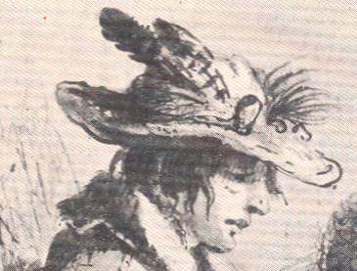 Pierre Rocky Mountain Trapper by A.J. Miller, 1837

We do not see beaded, quilled or horse hair hat bands, brims pinned up, various safety pins, vent picks, gun worms, blanket pins, pendicular pins, rendezvous pins, HBC & NWCo pins, pewter buffalo skulls, etc. pinned on the hats. Doesn’t mean that it didn’t happen, except for the items that did not exist then. The French voyageurs or boatman were particularly noted for adorning their hats as we see in historic sketches or paintings from Hopkins, Krieghoff, and Rindisbacher. Frenchmen and Indians were found of adorning their hats or headgear with ostrich plumes and colored feathers, which were being imported for the Indian Trade:

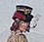
Rindisbacher 1823
Now and then a chance party of "Northwesters" appeared at Mackinaw from the rendezvous at Fort William. These held themselves up as the chivalry of the fur trade. They were men of iron; proof against cold weather, hard fare, and perils of all kinds. Some would wear the Northwest button, and a formidable dirk, and assume something of a military air. They generally wore feathers in their hats, and affected the "brave." "Je suis un homme du nord!"-"I am a man of the north,"- (Irving, Washington. Astoria, or Anecdotes of an Enterprise Beyond the Rocky Mountains).

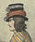 Rindisbacher 1824

…our Canadian boatmen, having their hats decorated with parti-colored ribands and feathers, (Franchere’s Narrative of A Voyage to the West Coast, 1811-1814).

So if you’re persona is an Indian, half-breed, French or voyageur, an ostrich plume may be appropriate. If you’re persona is not one of these it is probably less likely that you would have done it. However, there were lots of individuals then as there are now, so it could be, since we can document the ostrich plumes and various colored feathers being available in the trade.

Trying to recruit more voyageurs for their westward journey, Mr. Hunt…tried another temptation… Among the recruits who had enlisted he distributed feathers and ostrich plumes. These they put in their hats, and thus figured about Mackinaw, assuming airs of vast importance, as "voyageurs" in a new company, that was to eclipse the Northwest. The effect was complete. A French Canadian is too vain and mercurial a being to withstand the finery and ostentation of the feather. Numbers immediately pressed into the service. One must have an ostrich plume; another, a white feather with a red end; a third, a bunch of cock's tails. Thus all paraded about, in vainglorious style, more delighted with the feathers in their hats than with the money in their pockets; and considering themselves fully equal to the boastful "men of the north."(Irving, Washington. Astoria, or Anecdotes of an Enterprise Beyond the Rocky Mountains).

We see reference to a variety of other hats too, such as top hats, carriage hats, Scotch caps, balmorals, clerk’s caps, knit caps, straw hats, military style forage caps, etc. We can find these both in the period sketches and in the fur trade records for our time period.

2 Straw hats $2 (Invoice of Sundry Merchandise sold and delivered to the Missouri Company by Fr^{s} Regnier at St. Louis, 1809)

Here’s one that might work for your Spanish or Southwest persona. It comes from Josiah Gregg’s 1844 Commerce of the Prairies describing the styles of dress in New Mexico … a sombrero — a peculiarly shaped low crowned hat with wide brim, covered with oil cloth and surmounted with a band of tinsel cord nearly an inch in diameter. You just have to decide the probability of those having been around or available prior to 1840, which they very well may have been.

Scotch Hats or Caps

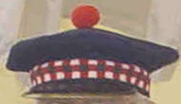 Many of these caps were wool and may be brimmed or un-brimmed. Many show the ball on top, others do not. Previous documentation indicates that the ball on top may have been a military hat, may have been more common on military hats or at least had a military origin.
Some of these hats or caps may actually have been military surplus or military hats. Again some of these hats and adornments may be more reflective of your geographic and ethnic origins and may not be universally worn by everyone. However, it does sometimes seem that there are more Scotch caps and balmorals worn today, at modern rendezvous, than there were during the 1800-1840 Rocky Mountain fur trade.

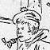
Rindisbacher-Red River Settlements 1824.

These Scotch type hats/caps seem to have been more common and more readily available in Canada through the NWC & HBC then from the American companies. They are very comfortable and practical hats/caps, which probably led further to improve their popularity. Here are a couple of period sketches of Indians wearing the Scotch type hats:

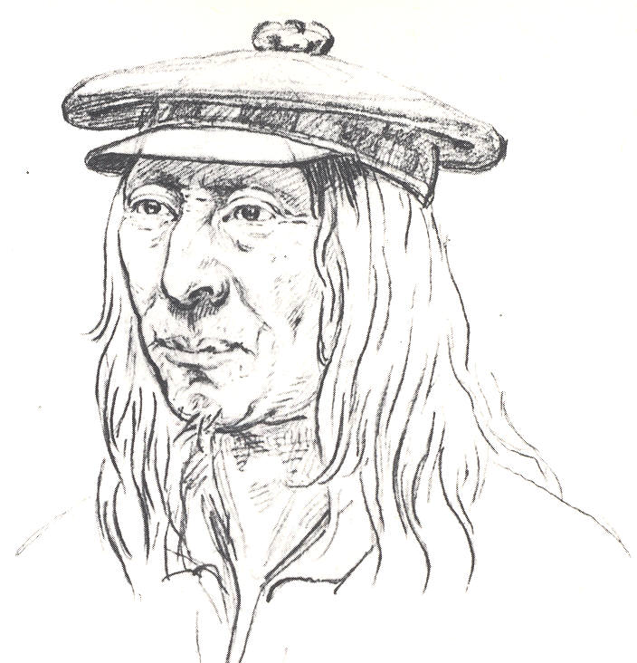
This first sketch by Gustav Sohon, is of the Iroquois Guide Aeneas wearing a typical Scotch cap. He was living among the Flathead at the time. Father Point also shows these as identical to those worn by the Nez Perce. There were quite a few disaffected Eastern Indians in the western fur trade and the Iroquois were common among them, both in the American and Canadian fur trade, and of course there was an HBC influence with these tribes too. So if your persona is for an Iroquois working in the fur trade this may be your hat.

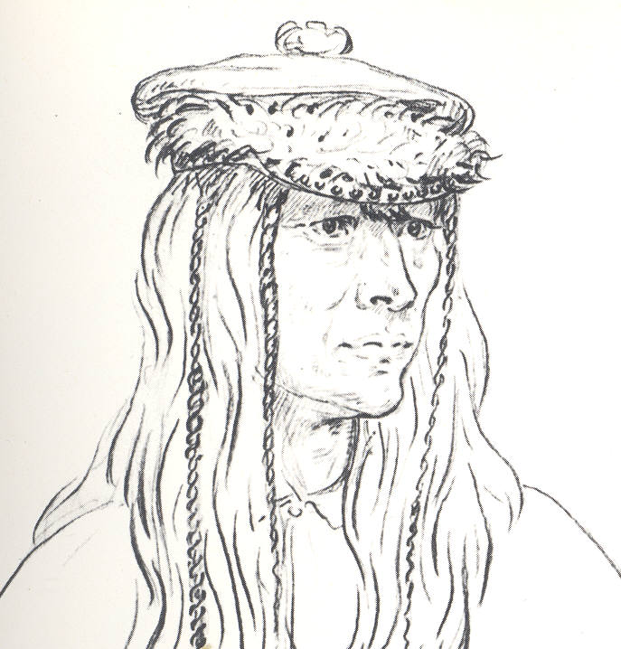

The second sketch is of Adolphe a Flathead Chief
also drawn by G. Sohon. Here he is wearing an almost identical Scotch cap as Aeneas wears above, but it is decorated with fur around the band. These Scotch caps or this Canadian influence is common in the northwest (Washington, Idaho & Montana) as the HBC had numerous posts in the area.

Top Hats

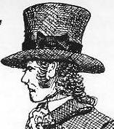

Top hats are seen in the variety of hats depicted in James A. Hanson’s Voyager’s Sketchbook. Top hats seem to again be a French ethnic preference, at least for the common man, as they are more dominant in their depictions, especially among Voyagers and Indians. Other top hat wears seem to be the more wealthy and affluent, company officers or government representatives at treaties and other formal occasions.


Frenchmen - Rindisbacher 1823 & 1824.

Rindisbachers’s period sketch & paintings depict a number of folks wearing top hats, and would again indicate that top hats were very popular with French Boatmen.

Additionally, The Mi’kmaq Portrait Collection, http://museum.gov.ns.ca/mikmaq/1801intb.htm, from the 1830s show that these Indians, both men and women also liked the top hat. These Mi’kmaq sketches also reflect the documentation in the written record for this preference of hoods (in a later section) among some western Indians too.

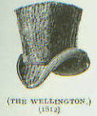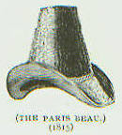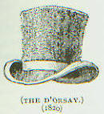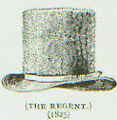
Several styles of beaver Top Hats from 1812-1825. Taken from Company of Adventurers by Peter C. Newman.

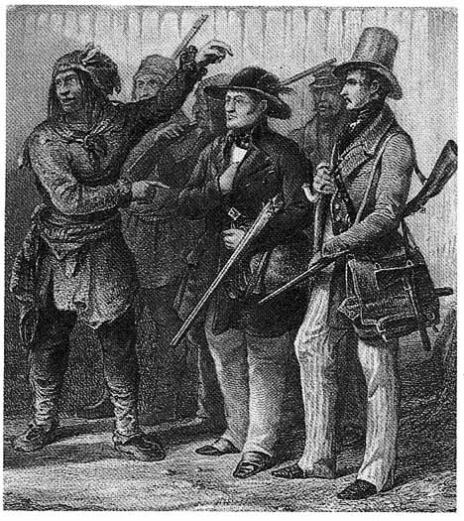
Here is Bodmer’s painting (1833-34) of he and Prince Maxmillian at Fort Clark. The interpreter on the left pointing at the Prince is supposedly Toussaint Charbonneau formerly of the Lewis & Clark expedition. This is unknown headgear here on old Toussaint. Those “Frenchies” are always trying to make a fashion statement. However, the Prince is wearing the typical low crowned wide brimmed wool felt hat and Bodmer is wearing a top hat. Between the Prince and Bodmer can be seen a man wearing a Clerk’s cap.

Finally here’s one of my favorite top hat pictures. This is an engraving in George Cartwright’s Journal of 1770-1786. This is a portion of the engraving titled, Captain Cartwright visiting his fox-trap. Cartwright, always the fashion statement, still wears his top hat in freezing temperatures. He is also wearing, what appears to be, a cloth & fur wig and chin cloth (G. Cartwright, A Journal of Transactions and Events during a Residence of Nearly Sixteen Years on the coast of Labrador. Vol. 1, 1792. Collection of the Bibliotheque municipale de Montreal, in F. Back, 2004. Museum of the Fur Trade Quarterly. Winter 2004. 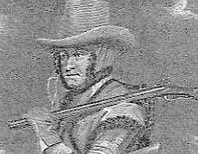

Clerk’s Caps

Clerk’s caps are the soft cloth hats with a brim and sometimes a band at the bottom. They became popular starting in the early 1800s and lasted in various styles for many years into the early 20th century. These soft caps were made of wool, corduroy, blanketing, linen and other materials with brims of leather or fabric. This is one very useful cap that is probably over looked and under utilized in our modern Rocky Mountain fur trade interpretations.

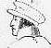
Rindisbacher, Red River Settlers 1820.
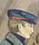 Rindisbacher, 1824.

There are a number of other Rindisbacher sketches & painting showing the clerk’s cap: Colonists on the Red River in North America, Two of the Companies Officers Travelling in a Canoe, and Two Young Men Hunting and Winter Voyaging in a Light Sledge. If you want to make a Clerk’s Cap see J. Gottfed’s article Reproduction Clothing – A Clerk’s Cap, on the Northwest Journal website, http://www.northwestjournal.ca/XII3.htm.

Isaac Cowie, The Company of Adventurers, wrote that the common outfit for clerks when traveling was…[a] navy blue cap with leather peak (C. Hanson, Jr. 1990. The Traders’ Dress. Museum of the Fur Trade Quarterly. Vol. 25, No. 1, Spring 1990).

These hats were very common in Canada and in the trade forts in the United States. In one of Ranney’s paintings, called “Pipe of Friendship,” a western traveler is shown wearing a tall version of the Clerk’s cap. Ranney’s painting is about 1850. These tall clerk’s type hats also look much like the fatigue or forage caps worn by the army at this time.
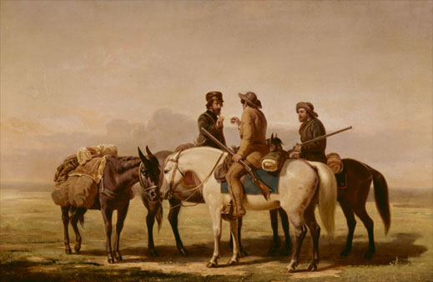

Hoods
The Mi’kmaq hoods, commonly worn by women, may have been the origins of the hoods that we see Mountain Men wearing in so many of A.J. Millers sketches from the 1837 rendezvous. More of these may be seen at: http://museum.gov.ns.ca/mikmaq/1801intb.htm. It seems that Cree and Metis men of the west are also depicted wearing these types of hoods, although I have not yet found and illustration of them.

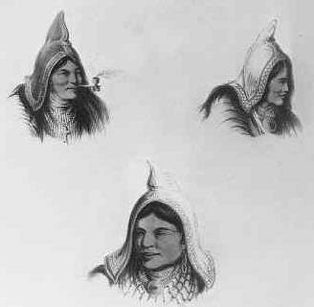
Lithograph by Robert Petley (1837) of Three Mi'kmaq women's heads, National Archives of Canada, Ottawa. Although commonly worn by women this seems to be a universal style among the Mi’maq and other Indians of the Great Lakes region. With many disaffected “eastern’ Indians moving west with the fur brigades, it has been assumed that the “hoods” depicted by Miller in 1837 may have had their origins with these eastern Indians. In fact Chronister and Landry (Clothing of the Rocky Mountain Trapper, 1820-1840, Book of Buckskinning VII, Scurlock Publ. Co., Texarkana, TX) say that …similar cloth hoods were worn by Indian people of the Great Lakes region and Canada throughout the first half of the nineteenth century. Clth hoods could have been an item adopted by the American trappers from the”Canadian half-breed or Indian trappers who worked for Hudson’s Bay Company.

Here’s another Indian woman with a decorated cloth hood. This is a watercolor painted at Moose Factory on James Bay around 1804-1811. The color reproduction is on the front cover of the Winter 2004 Museum of the Fur Trade Quarterly and came courtesy Hudson’s Bay Company Archives. The woman appears to be wearing an additional cloth or fur “wig” under the hood and a fur chin cloth. The wearing of fur

“wigs” and chin cloths are seen commonly in the cold Canadian north.
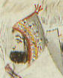

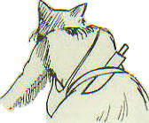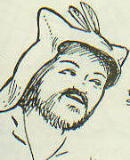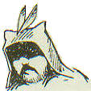
Pictures from Rex Norman’s The 1837 Sketchbook of the Western Fur Trade. All Pictures are redrawn from A.J. Miller, The left picture is from Approaching the Buffalo, the middle picture is from The Trapper’s Bride, and the right picture is from A Trapper in his solitary Camp. This is an excellent reference and resource.

The hunters form for themselves a peculiar kind of cap;-it has two ears with a flap reaching to the shoulders...peculiar caps…are made by themselves [trappers], to replace felt hats, long since worn out or lost…(A.J. Miller, 1837. The West of Alfred Jacob Miller). 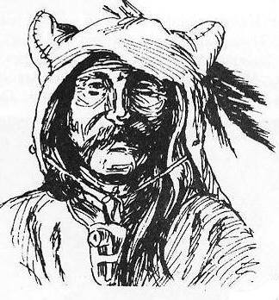
Drawing by Ronald Kil, Book of Buckskinning VII.

Hanson & Wilson describe these blanketing hooded caps being made in two styles, the Liberty Cap Style and the Wolf Ears Style, both of which are shown in Miller’s 1837 sketches. More information on making these hoods may be found in The Mountain Man’s Sketchbook, Volume One (J.A. Hanson & K.J. Wilson, 1982. The Mountain Man’s Sketch book Volume One. The Fur Press. Chadron, NE).

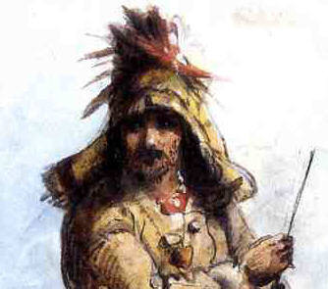
Here is a portion of Miller’s painting, from sketch, of Louis, Rocky Mountain Trapper. This is an elaborately decorated hood and it is difficult to see if it is the “wolf-eared” or liberty style.

Kerchiefs or Headscarves
Common among the French, especially the boatmen or engages was either the wool toque or a kerchief. The kerchief was worn to hold another hat down in high wind or was worn tied around the head like a bandanna or headband. Being tied either in front or back. In cold weather it was tied like a woman’s headscarf or over the ears. Research of the various sketches and drawings of the French engage, trappers, traders, settlers, etc. does not show the kerchief being worn “pirate style”. There are references to knotted kerchiefs being worn, but the only sketches, other pictures or detailed descriptions from the period do not show the pirate style. It may be the Hollywood pirate or Zorro movies that have popularized this type of wear. Chronister and Landry (Book of Buckskinning VII) state that the use of bandannas or silk scarves as head coverings, …like many other aspects of mountaineer dress this adaption is probable but none of the journals or art work from the period provide and documentation for this usage. This manner of head covering may have been more favored by the river men or engages than by the rocky Mountain trapper. Artists of a later vintage such as Kurz and Ranney, both from the 1850s, semmto be the main pictorial sources of [any] bandanna head coverings.

Consequently, and contrary to popular practice at modern rendezvous, and the many modern drawings and paintings of the Fur Trade, we have not been able to document, in our time period or before, headscarves being worn pirate style. The only sketch I have ever found comes from an 1850 Ranney painting called “On the Wing,” of waterfowl hunting in an eastern marsh. Don’t know about waterfowl hunting in the 1850s, but wearing a red head scarf and a red shirt waterfowl hunting today would not be very productive. 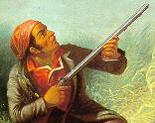

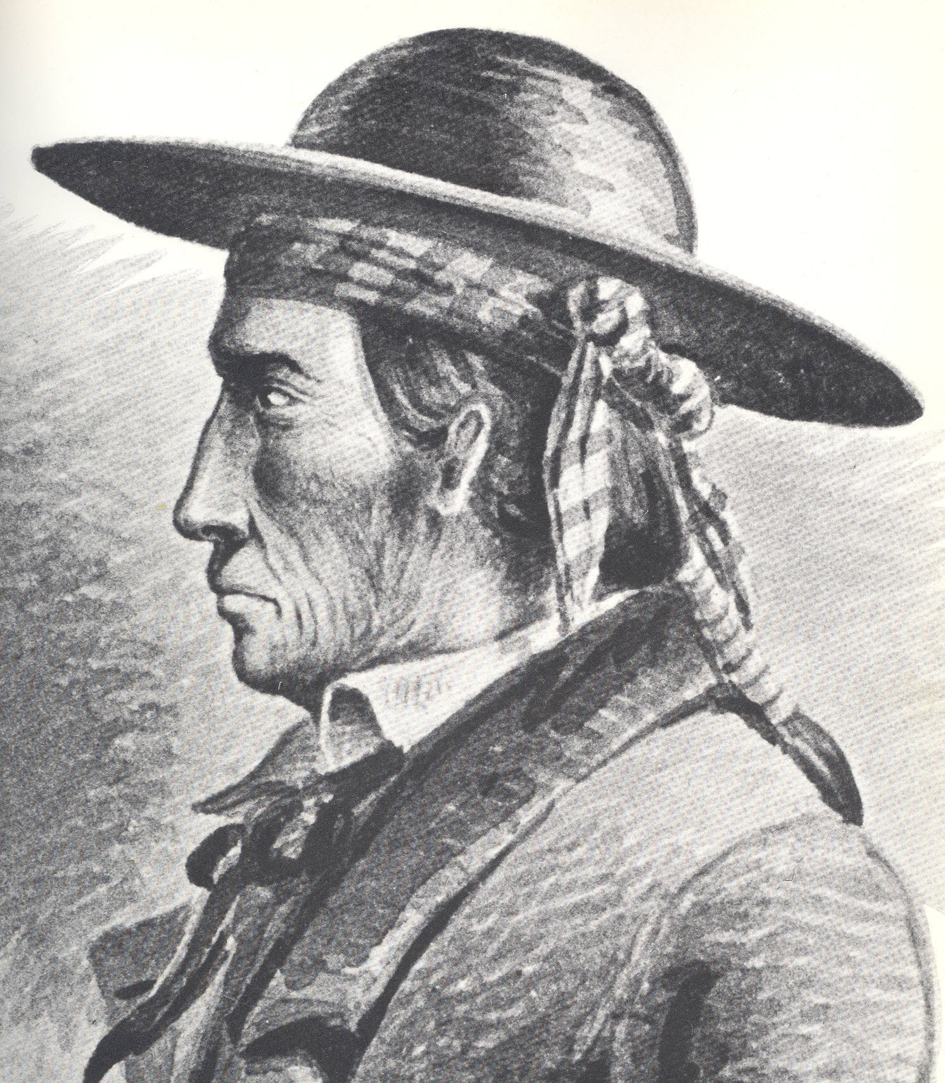
Another documented headscarf is worn by a Navajo Chief, Marianos Martinez, who was sketched and then painted by E.M & R.H. Kern in1849. Some have used this painting as justification for wearing a “pirate” scarf under a hat. However, this seems to be more a head bandanna tied on the side, in the Navajo style, rather than a pirate scarf. I guess if you were doing a Navajo in the fur trade this look could be for you. Notice in this sketch that he is wearing the typical low crowned, wide brimmed, wool hat. There are a number of other sketches showing the wearing of a head scarf under a hat in the southwest and California areas. On closer examination they all seem to be of the head bandanna tied to the back or side and then a hat worn over it.

The question, of the wear of a “pirate” scarf, whether alone or under a hat, has not been answered definitively. Our good friend Todd Glover, Poison River Party, says …My opinion on this is that it is one of those hairs to be split. We know they had scarves, and there are only so many ways to wear one. I would think that it would occur to them to wear one pirate style on occasion. Can't prove they did, can't prove they didn't. I think the question is akin to did they tuck their shirts in or not? Most probably did, some didn't according to personal habits and standards.

“Finally, many men simply tied a handkerchief around their heads. If the cloth was big enough, this would be done as a turban, open at the top” (Rickman, Unknown; Ruxton, G. 1950. Ruxton of the Rockies. University of Oklahoma Press. Norman, OK; Parkman, F. 1969. The Oregon Trail. Edited, E.N. Feltskog. University of Wisconsin. Madison, WI; and Ewers, J.C. 1982. Artists of the Old West. Promontory Press. New York, NY).

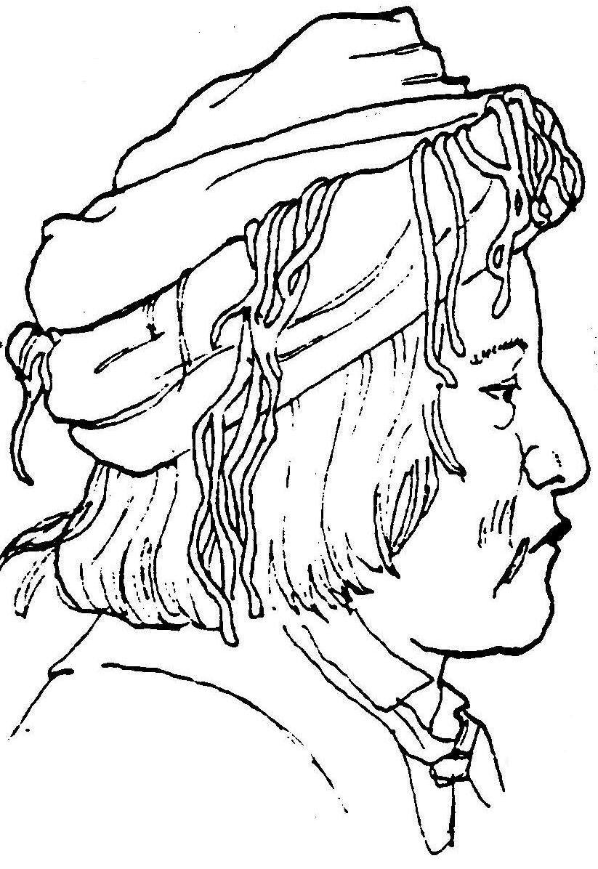
Many Indians are seen wearing kerchiefs or shawls as turbans. This sketch is of a Delaware Indian by Richard Petri 1850 (Newcomb, 1978, as seen in Rickman’ Costume Manual) is wearing a turban made from a fringed shawl or scarf. If your persona is for an eastern Indian, this style may be for you.

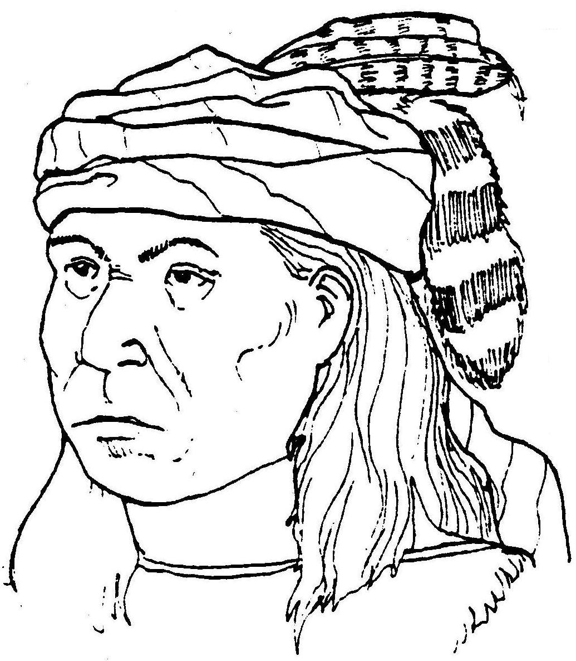
Here is the Walla Walla chief Peoped MoxMox painted by Paul Kane in 1847. He is wearing a turban, possibly inspired by Iroquois or Delaware Indian trappers living in the area. The feathers and raccoon tail are tied into the hair (Rickman’s Costume Manual).

Ruxton, Wild Life in the Rocky Mountains, upon returning to “civilization” in the 1840s was wearing a turban and says,
…I have no doubt that I myself came in for a share of staring, for I was dressed in complete mountain costume, with my mahogany-colored face shaded by a crimson turban a la Indien, and in all the pride of fringed deerskin and porcupine-quills; and I was paid the compliment of being more than once mistaken for an Indian chief; and on one occasion I was appealed to by two of the dragoons to decide a bet as to whether I was a white man or a redskin. One day I was passing through the dragoons' stables when the men were cleaning their horses, and my appearance created no little difference of opinion amongst the troopers as to what tribe of Indians I belonged to.
"That's a Pottowatomie," said one, "by his red turban."
"How long have you been in the west," cried another, "not to know a Kickapoo when you see him?"
"Pshaw!" exclaimed a third; "that's a white trapper from the mountains. A regular mountain-boy that, I'll bet a dollar!"

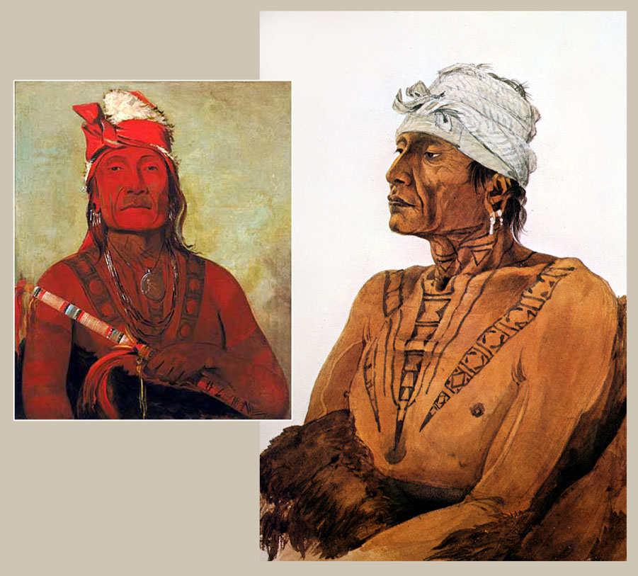

Here is a comparison of a Catlin and
a Bodmer painting showing a couple Indian worn kerchiefs as head gear.

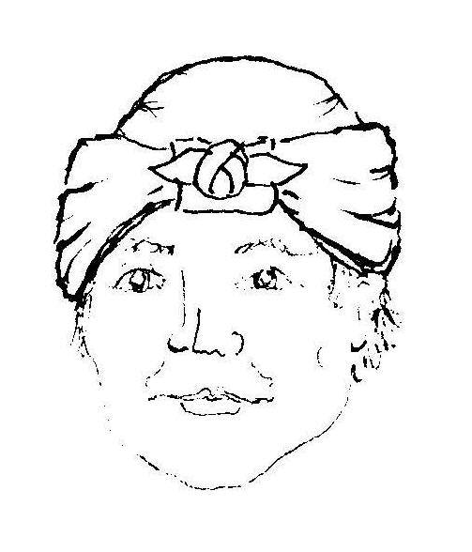
Sometimes summer caps were improvised from handkerchiefs. They were folded so as to cover the top of the head and tied together on the forehead ('cleaning lady' style), or made into a headband tied with a large bow in front. From: Peter Rindisbacher, 'Two of the Companies Officers Travelling in a Canoe Made of Birchbark Manned by Canadians' (Northwest Journal ISSN 1206-42).

One of the most common style of head and/kerchief wear is what we see typified in these Kurz drawings. The first is of an American Fur Co. engage’s [probably metis] as seen in Ewers (1981), Kurz, (1937) and Rickman. The second is of a well known Kurz sketch of the “Horseguard at Fort Berthold”.

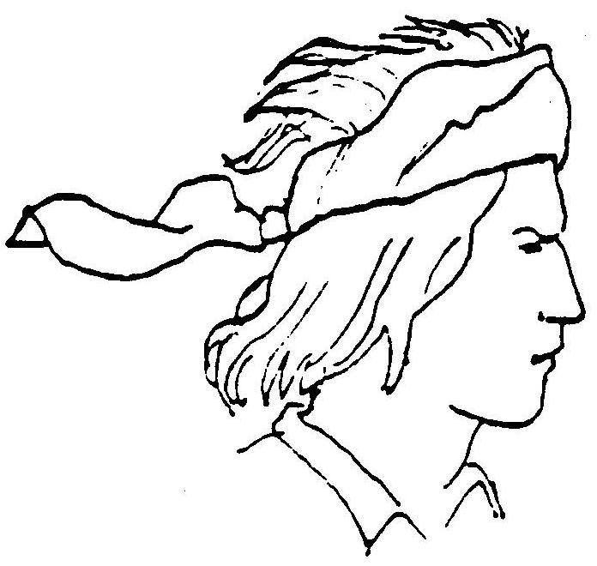

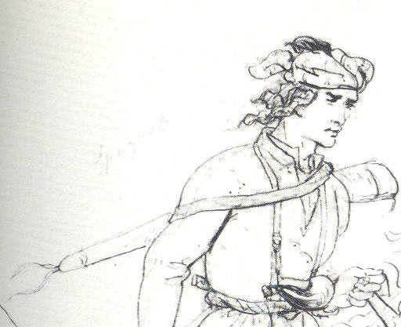

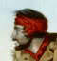 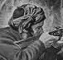 The Prairie Hunter American Frontier Life

Here are a couple more kerchief styles from 1800s western paintings.

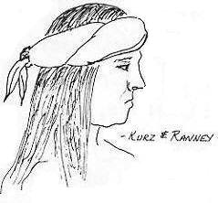
From Mountain Man
Sketch Book Vol. 1

The wear of kerchiefs does not seem a common practice outside of the French. For others you would be considered to be so low down on your luck, that you had no hat and were forced to wear a kerchief instead of a hat. However, as hats wore out, the wearing of kerchiefs may be come more common, especially during the summer. A silk scarf or a piece of linen would be a start for a cheap kerchief or neck cloth. The neck scarves were usually the same as the kerchief (36”x36”), and

usually solid colors with blue being the most popular for the French and black or red the predominant colors of silk scarves seen in the inventories. These kerchiefs would be appropriate summer head coverings worn headband or bandana style. For more on some styles of kerchief wear see J.A. Hanson’s Vohager’s Sketchbook from the Fur Press in Chadron, NE.

Toques
Toques make excellent cool or cold weather caps. There are many styles and methods of wearing these hats, and we refer you to the Voyager’s Sketchbook by James A. Hanson for more references on ways to wear the toque and on other types of hats worn by the French. Two styles of toques are noted in journal accounts: the single and the double cap. A single toque resembles a simple modern stocking cap, while the double toque resembles a deflated football with one end stuffed into the other to form a double layer. Depending upon how deep you stuff one end into the other, it is possible to adjust the “drop” or “bag” of the double toque… The distinct fashion statement of the toque was the “bag” of the cap, which is the leftover portion that hangs from the head (K.A. Koster K.A. 2002. Les Pays Den Haut, When is a Tuque, Not a Tuque? On The Trail Magazine).

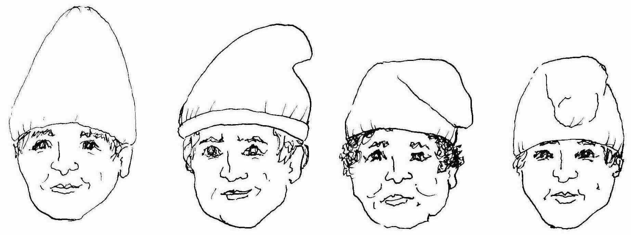

Some styles of wearing the toque, often shown in period sketches and paintings

A pattern for knitting this correct style of toque is available in Mark Tully’s “The Packet II” (M. Tully 2000 The Packet II – Being Another Collection of Patterns, Articles and Essays of Particular Interest to the 18th-Century Re-Enactor. Ballindalloch Press. Baraboo, WI).

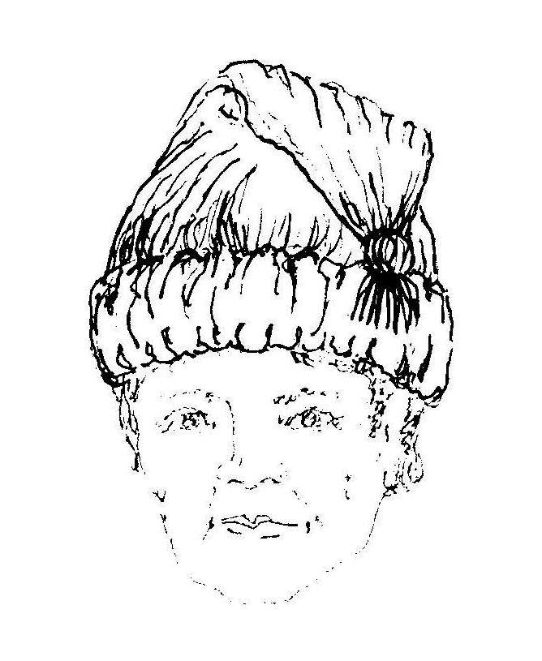
Modern Toque

Toques or tuques were worn by most everyone and not just the French. Toques are knitted wool hats, but they are not usually like most of those that are sold and worn at modern rendezvous with the knitted “ribbed” look. The most common colors among French voyagers were blue or scarlet. But other colors are used too, with natural colors & green also being documented. Toques did not have “brow-folds” or turned up edges, nor the different knitted ridges on the bottom ends, nor did they usually have tassels on the end. These are things we so commonly see on today’s “buckskinners.” This same style of hat was not always knit, especially, in the earlier days, but were often made of wool fabric, blanketing or blankets too.

The wearing of trade silver or other adornments such as feathers, ribbons, badges, and beads upon the toque severely lacks support historically in journals and artwork (Koster, K.A. 2002. Les Pays Den Haut, When is a Tuque, Not a Tuque? On The Trail Magazine).

Here are a few toques in historic sketches & paintings. Both Rindisbacher and Krieghoff show over and over again the plain bag style toque, most commonly in Red. You’ll notice no ribs, no tassel, no pins or other junk stuck on the hats.

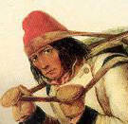
French Traveler by Rindisbacher.

Canadians wearing toques by Cornelius Krieghoff.
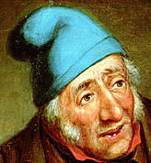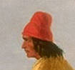

Canadian Cap

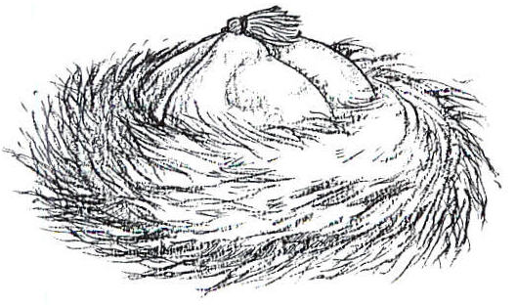
B. Moore, We Proceeded On, 2001.

Wool Canadian Caps with their fur bands have been around since at least the middle 1700s. These are nice looking warm hats and they are easily constructed. The cap is made from four or more wedge shaped pieces of wool or blanket material sewn into a beanie. These pieces can be doubled and/or lined with linen, fustian or cotton. You can take your measurements from the segments of a favorite baseball cap. Either a separate band, about 3” wide, can be sewn around the bottom, or your “football” sections can be lengthened and then turned up on the sides about 3”. Fur is sewed on this band and it forms a large fur band around the cap.



The Canada Cap is well documented for use in the 18th and into the 19th century. The artist F. VonGermann depicts the cap being worn circa 1766 by a British soldier at Michilimackinac. Two decades earlier, celebrated English artist William Hogarth, wearing a Canada cap, captures himself in a self-portrait. From before the French and Indian War through the Revolutionary War the Canada cap is evident. It is said Benjamin Franklin himself donned one and wore it when he lived in Paris.

Another example can be seen in the Eastman Johnson painting Washington Crossing the Delaware (1851). Later, in the 1860s another celebrated artist, cartoonist Thomas Nast, established the look of “Santa Claus”. Santa may be the most popular wearer of the Canada cap (Koster, Grand Portage National Monument).

When the bottom fur band is pulled down the band forms earflaps with the fur next to the skin. Fox and raccoon were common, but coyote also makes a good fur band. Many times the cap had a fur “pom,” tassel, wool pompom, feather(s) or tail on top in the center. These are easy simple caps to make and The Book of Buckskinning II, the Manuel for Interpreting Lewis & Clark, and Beth Gilgun’s Tidings From The 18th Century all give details on how to make a Canadian Cap.

Indian Style Fur Caps

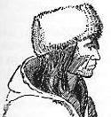
The Horse in Blackfoot Indian Culture with Comparative Material from Other Western Tribes, 1955. J. Ewers, Smithsonian Inst. Press
Indian style fur hats or turbans were probably made or procured by mountain men for winter wear, although fur caps are only occasionally mentioned. Indian fur caps were simple turbans of fur with open tops. Turbans were commonly made from a 3”-4” wide stripe of critter fur from head to tail. The tail and what ever is left over, depending on the critter, meet in the rear. On some “hats” the split legs and/or tails of the animals may have been left on and hanging down the back or sides. These turban type hats were sometimes improved upon by lining them with wool or other fabric and closing the tops. Ewers (1955) goes on to tell us that the Blackfeet make winter caps of hair-on buffalo hide with earlaps [flaps], and that these are worn by both sexes. Ewers doesn’t give us a time frame, but his informants are old time buffalo Indians. So this may be an adaptation of white style hats.

Here is an almost identical Nez Perce hat as the Blackfoot, by Stephen Shawley 1974.
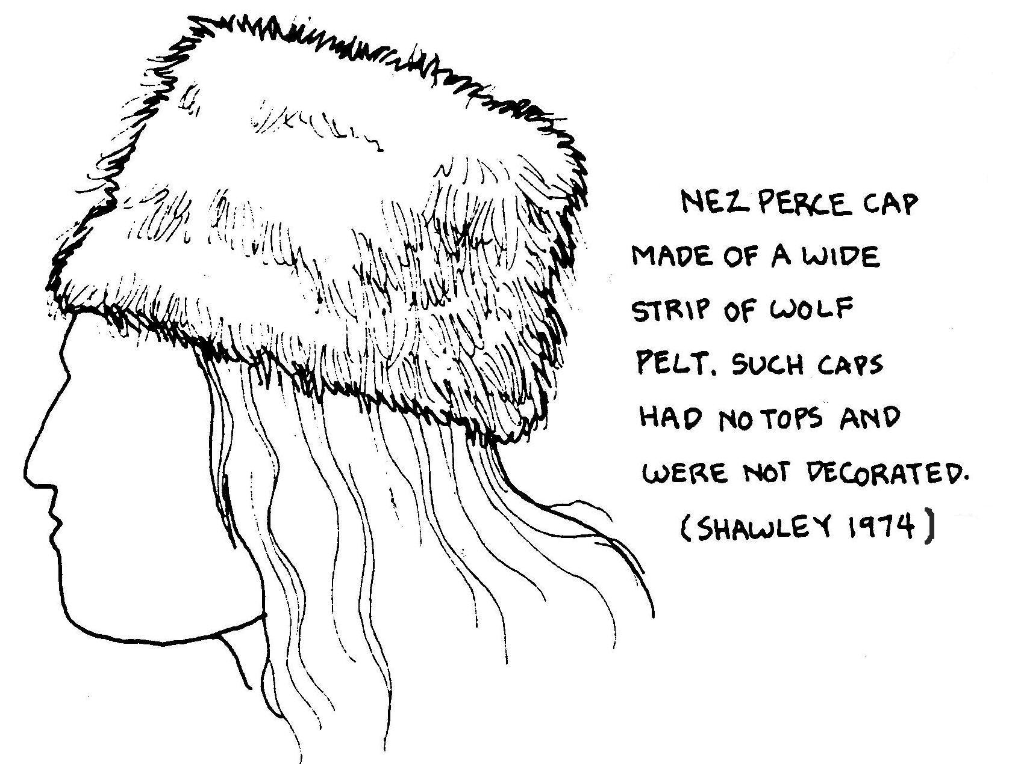

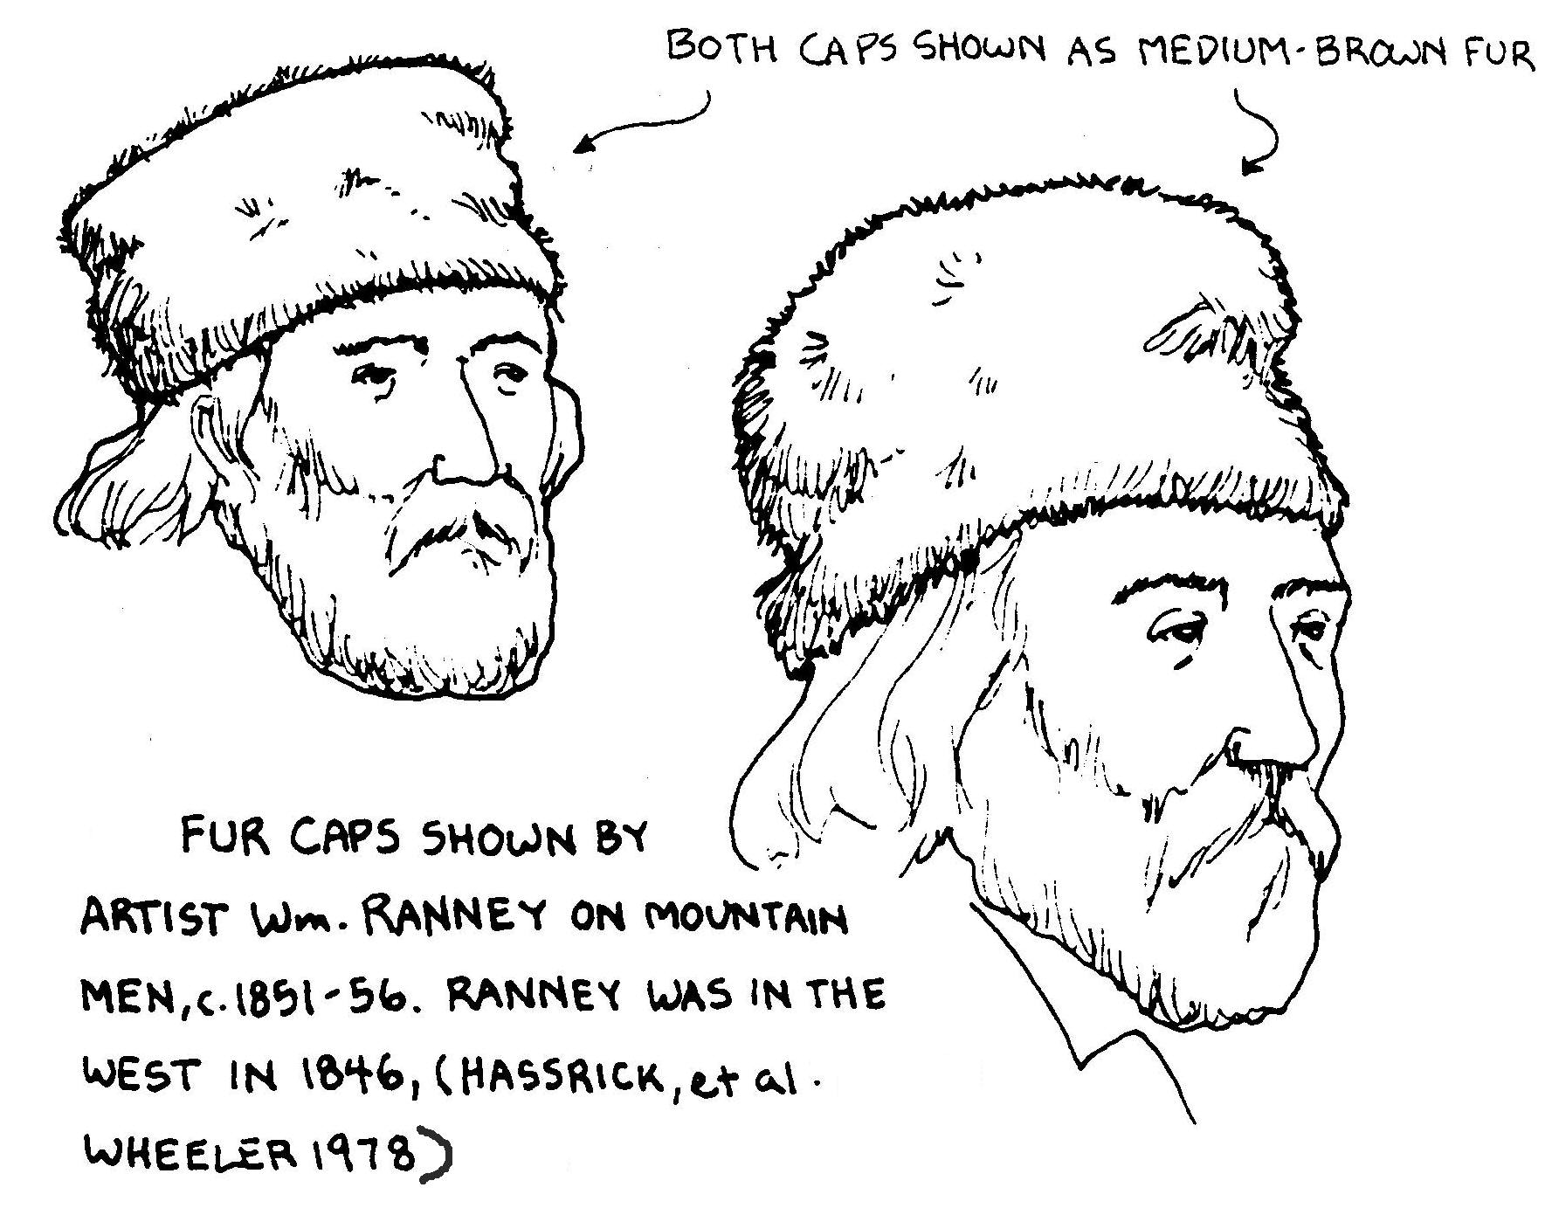
Here again are some very similar fur hats worn by whites and depicted by the western artist Ranney in 1846.

Other Winter Hats
For some good information on winter clothing I would recommend the article Winter Traders’ Dress in Eighteenth-Century Hudson Bay, by Frances Back in the Winter 2004 Museum of the Fur Trade Quarterly. Even though this is 18th Century Hudson Bay, some of the example sited here are early 19th century. Additionally, The Northwest and Hudson’s Bay companies were in both the Canadian and American Rockies and many Canadians were also employed in the American Fur Trade.

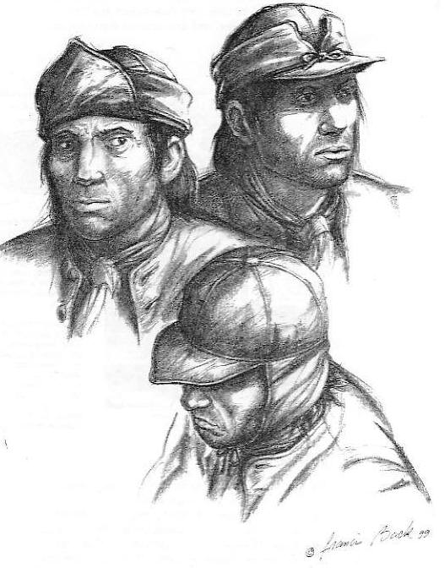 These tapabord caps shown here are by Francis Back in Back’s article in the Museum of the Fur Trade Quarterly, Summer 2000, Vol. 36, No. 2. Back tells us that this …was a sailor-type cap popular among the hatitants and the Indians during the 17th century. According to the weather, the visor and ear-flaps of the tapabord could be worn up or down. Back’s drawings here are based on surviving examples in European collections and on contemporary depictions, especially those of Sebastien Le Clerca showing Micmac Indians wearing these tapabords. Back goes on to tell us that tapabords listed in trade goods are …sometimes colorful, such as blue lined with red, but usually they were of grey cloth. There is no evidence that I could find for this hat continuing into the late 18th or 19th century. However, it seems to be the for-runner of the brimmed cap with fold down ear-flaps that are popular all through the 19th & 20th centuries. These later hats are commonly made of wool or fur.

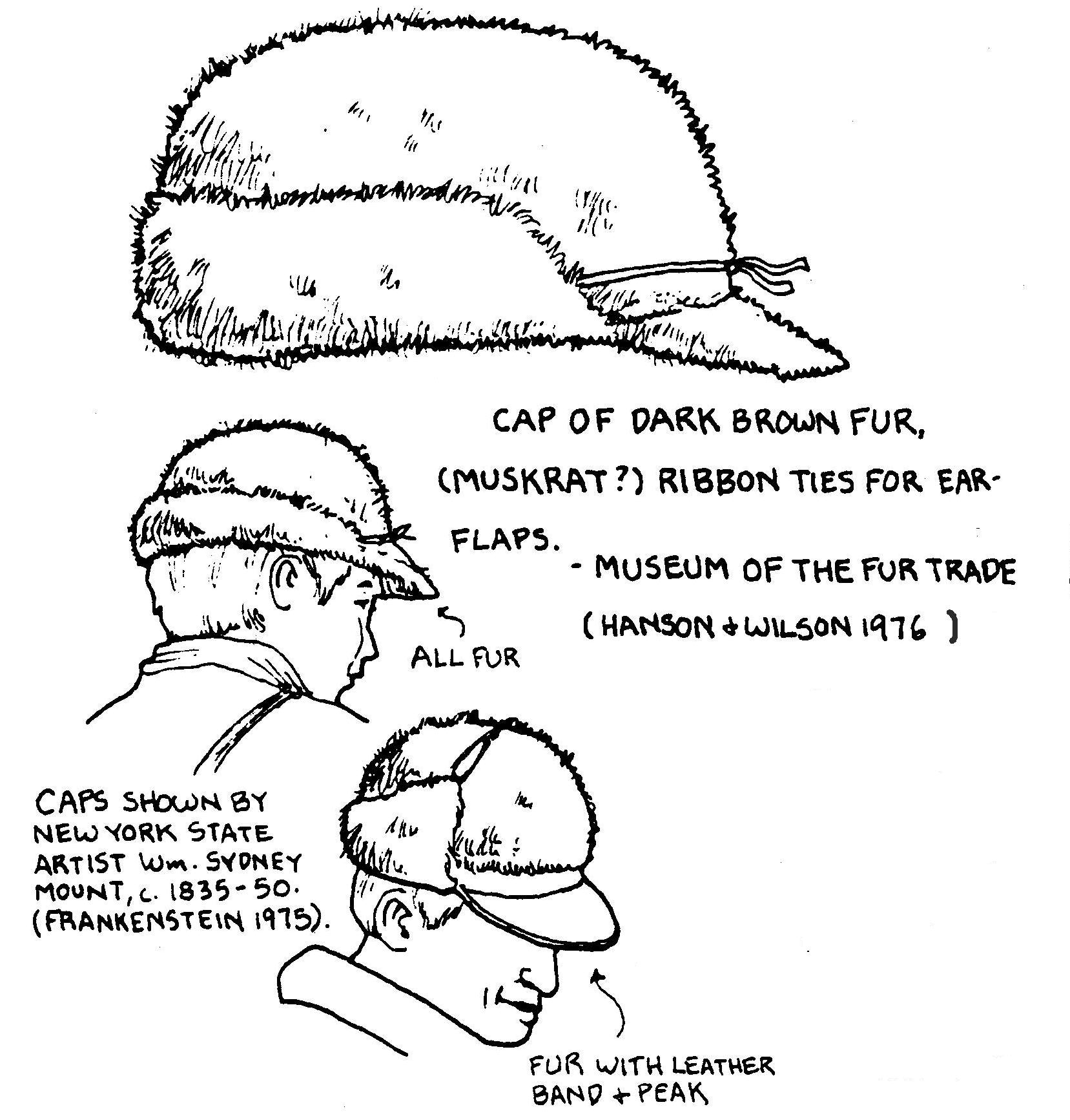
Here is what may be a continuation of the tapabord, commonly made from wool or fur. This more modern looking fur hat, shown in Rickman’s, Costume Manual for Sutter’s Fort, is circa 1845. These pictures were taken from Hanson & Wilson’s The Mountain Man’s Sketch Book, Volume II from the Museum of the Fur Trade. Unfortunately we are not given any time frame for these hats, other than the middle sketch by an artist done between 1835-1850.

Chronister and Landry (Clothing of the rocky Mountain Trapper, 1820-1840, Book of BuckskinningVII, Scurlock Publ. Co. Texarkana, TX) refer to an extant example of a fur cap …made much like a modern winter cap, complete with ear flaps and visor… Perhaps this is the “Wolfskin cap” that Charles Larpenteur lists with his personal clothing when he goes to work at Fort Union.
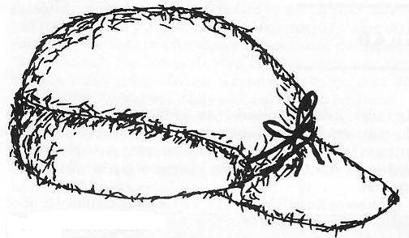
(Drawing from Book of Buckskinning VII.)

For winter fur caps we have limited information. Osborne Russell mentions in Journal of a Mountain Man, that A Trapper’s equipment consists or … a hat or Cap of wool, Buffaloe or Otter skin. The daughter of the Mountain Man Jim Bordeaux said that western trappers generally made their caps of cheap furs like skunk, kit fox or badgers, and sold their good furs to the traders (C.E. Hanson, Jr. 1979. The Mountain Man’s Outfit. Museum of the Fur Trade Quarterly. Vol. 11, No. 3). In A List of the various articles…taken from the invoices furnished by the Traders at the Superintendency St. Louis…1831 they list 24 men’s fur hats, no idea what they are though.

HBC employees wore caps, “the crown of which is of cloth, the flaps of which reach down on the shoulders, and button close under the chin, are of beaver skin; and those who do not use caps, have martin or cat-skin wigs.” From Voyages of Hyudson’s Bay in Search of a Northwest Passage, 1741-1747, The voyage of William Moor and Francis Smith, 1746-1747 in F. Back, 2004. Museum of the Fur Trade Quarterly. Winter 2004)…In mild weather, an otter skin wig or cap is worn, having a broad piece of the above skin ‘round it,’ the crown of cloth lined with linen; but when the cold is great or snow drifting much, another kind of cap is used, the crown also of cloth but lined with flannel; and has a large flap or cape which comes down over the shoulders, and ties under the chin. The face is defended by a chin cloth made of bveaver, duffle, flannel or blanketing; it comes under the chin, over the cheeks and ties with strings on the crown of the head under the cap; so that little more than the eyes, nose and mouth is exposed to the air (From Andrew Graham, Observations on Hudson Bay, [written from 1767-1791], Hudson’s Bay Company Archives in F. Back, 2004. Museum of the Fur Trade Quarterly. Winter 2004).

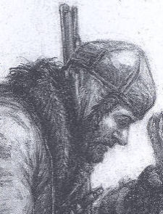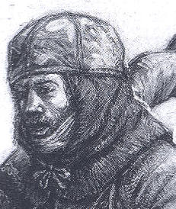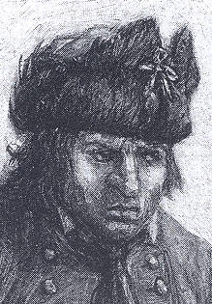

Here are three hats drawn by Francis Back in the article Winter Traders’ Dress in Eighteenth-Century Hudson Bay, found in the Winter 2004 edition of Museum of the Fur Trade Quarterly, Vol. 40, No. 4. The objects shown in these figure were taken from artifacts in the Canadian Museum of civilization. The caps in the first and second pictures are worn over “fur wigs” and on the second also has a “chin cloth.” Both these pictures show skull caps made from sections like those of a Canadian cap. The third hat is a cloth [wool] skullcap with fur earflaps that could be worn up or down.

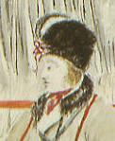

Here’s another fur hat from Canada. This smaller piece is taken from a watercolor painted at Moose Factory on James Bay around 1804-1811. The color reproduction is on the front cover of the Winter 2004 Museum of the Fur Trade Quarterly and came courtesy Hudson’s Bay Company Archives. This water color shows a fur cap with earflaps. At first glance it would seem to be skunk, but that is highly unlikely since this region is beyond the skunk’s historic range. Upon closer examination it is darker fur flaps tied up over a lighter colored hat body, which may be either wool or a lighter fur. In many ways it resembles the hat on the far right of the previous three pictures, but this one appears to have the ear/neck flaps rounded on the ends rather than pointed. Note the fur collar on the coat too.

Various types of winter hats or fur or wool were also worn. Here is a 1837 pencil sketch by James Wandesford Butler. And a second by Butler entitled “Hunter” from 1838. The first hat looks like what we would call a “Trapper’s Hat” today. The hat in the second sketch almost looks like the hat that Mark Baker wears. Both of these sketches are from Canadian subjects.

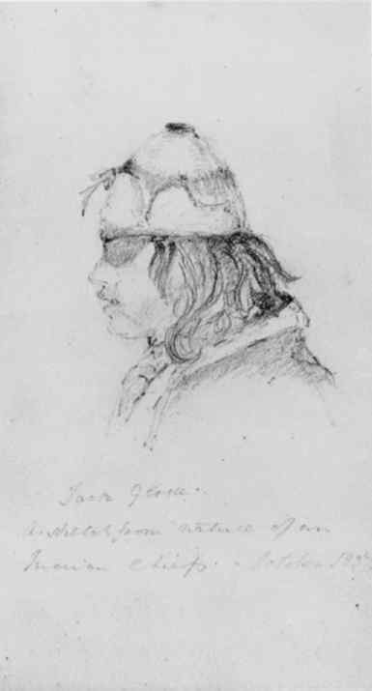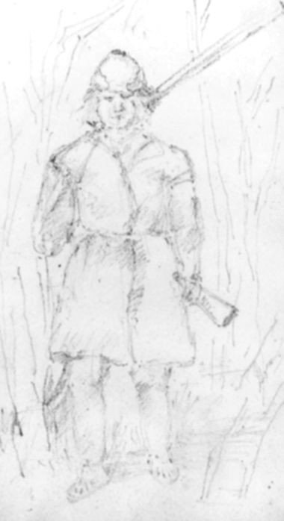

What is absent in all of the descriptions, period sketches and paintings of winter hats are the round beaver hats with the leather bills, which have become very popular at modern rendezvous and in modern mountain man or fur trade paintings. Another popular hat today is the fur drape or full animal pelt “road-kill” hats that have suddenly appeared and proliferated in the last 30 years. They too have no historic precedence. When you see a lot of guys wearing something at a modern rendezvous or in a Hollywood production, that looks “cool,” it should send up a “red” flag, as it usually turns out to be historically incorrect.

Other Headgear
We think it would be entirely appropriate, especially if your persona is a recently discharged “G.I.” or militiaman, to be wearing a military hat appropriate for the time you are depicting. There are a variety of hats that fall into this category and many mirror civilian styles or types of the time.

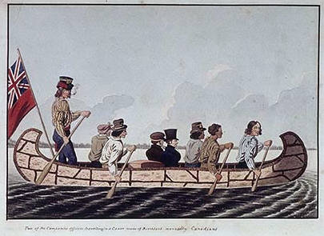
Here’s Rindisbacher’s 1823 painting of “Two Company Men Traveling in Canoe”. Notice that there are four top hats, one clerk’s cap and one kerchief (tied Aunt Jemima style) shown.

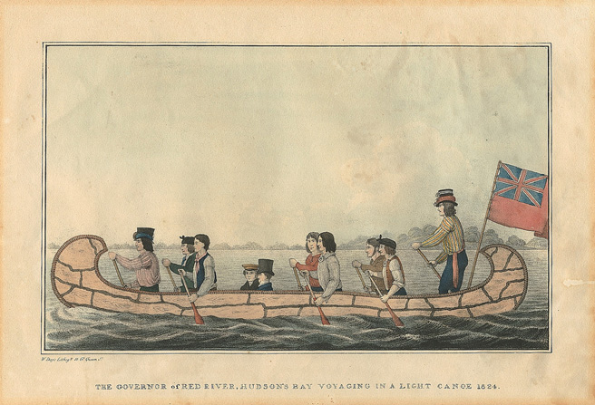
Here’s Rindisbacher’s 1824 “Governor of Red River, Hudson’s Bay Voyagers in a Light Canoe.” It looks a lot like the same guys going the other way. Here there are three top hats, an Aunt Jemima tied kerchief, and now there are also two clerk’s caps. It may have been the same crew as dignitaries were often conveyed by the HBC Governor’s personal voyagers & canoe.

